Use Case Diagram for Diabetes Detection
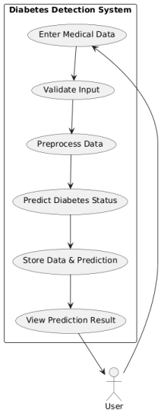
Data Flow Diagram for Diabetes Detection
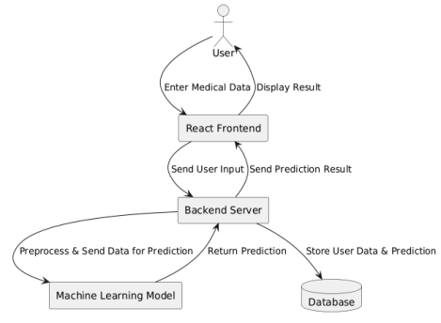
Class Diagram for Diabetes Detection
